# **Suspension system**

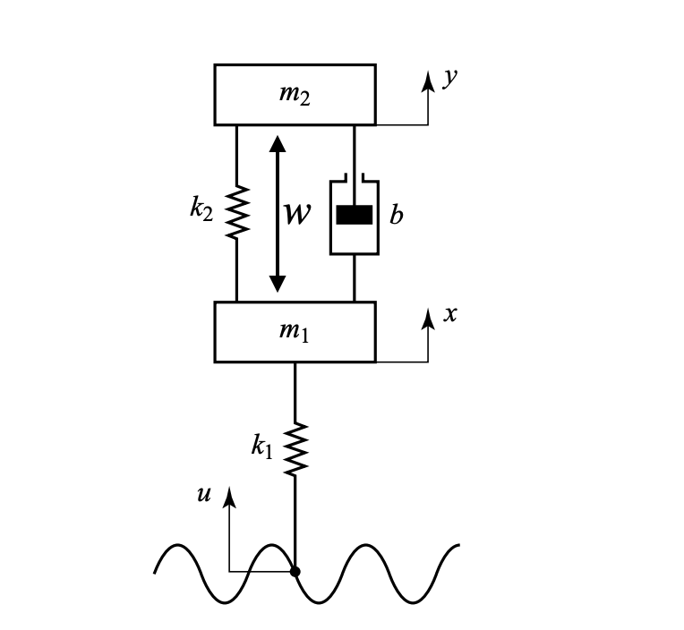

Figure 1. a schematic diagram of an automobile suspension system.

The vertical displacements at the tires of the vehicle serve as the motion excitation for the suspension system as it travels along the road. This system moves in two directions: the center of mass moves in one direction while rotating in the opposite direction. The entire system requires a complex mathematical model. Figure 1 depicts a very simplified version of the suspension system.

**Project**

1. System Modeling:
   * Develop a mathematical model of the system using first principles.
2. Controller Design:
   * Choose a control strategy.
   * Design the controller gains based on the system model and desired performance criteria, such as stability and response time.
3. Software implementation:
   * Use MATLAB to simulate the system and to implement the control algorithm in simulation.
4. Documentation and Presentation:
   * Document your work in a report summarizing the project, including the system modelling, controller design, and results analysis.
   * Make a presentation to discuss the project and present the results to the class